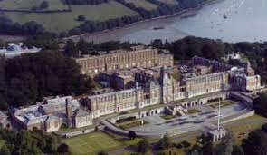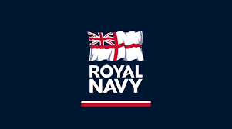

You may have been born anywhere, but you were made in the royal navy.

Sadly, although it is September 2020, it’s not quite the reunion we had planned– it’s a reunion themed quiz instead. OK, it’s a poor substitute, but the best we could do under the circumstances. We’ve all probably done a few quizzes over the past few months, but the Committee felt it was worth celebrating our reunion in spirit if not in substance. Speaking of spirit, we’ve even got some on hand to offer as prizes to encourage participation and stoke up a bit of inter divisional rivalry!
1st Prize – a bottle of Pickerings Naval Strength gin
2nd & 3rd Prizes – Pickerings Britannia Gin Gift Sets
Bonus Prize - A bottle of Naval Strength gin too for the best caption in Round 5.

Time Allowed – 30 minutes. (Not including the 5 Minute Rule) No sleeping at the back!
Deadline for submitting your completed papers – 1800 Sunday 27 September 2020.
The decision of the Committee is final. Unless we decide otherwise.
1985 rules apply, back then there was no Google. If you wanted to pass exams you either had to learn the stuff or cheat. So, in time honoured fashion, and to give you all a chance, we have included a hefty selection of “multi-guess” questions/answers. Carry on!

ROUND 1 – STAND BY FOR DIVISIONS!
There were 6 Divisions at Dartmouth back in our day, Blake, Cunningham, Hawke, Talbot, St George and St Vincent – but how much do you remember about the legendary naval figures behind the famous names?
Q1. Which body of water is famous in RN history as being the scene of the most significant triumph of Admiral Edward Hawke’s RN career?
A. Torbay
B. Biscay
C. Quiberon Bay
D. Whitley Bay
E. Bay of Gibraltar
Q2. During the Second World War, which port was home to Admiral Cunningham’s headquarters during his term as Commander in Chief Mediterranean?
A. Gibraltar
B. Malta
C. Piraeus
D Alexandria
E. Beirut
Q3. There are two of our 1985 Divisions, and their famous forebears, commemorated in this 1982 set of commemorative Royal Mail stamps. For 10 points, match the correct Admiral/monarch with his flagship. * 3 days Charlies for anyone who scores 4 points or less on this question.
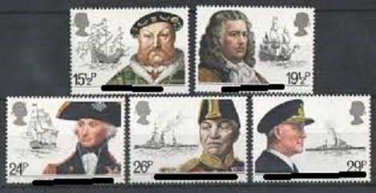
Lord Fisher – Lord Nelson – Admiral Blake – Admiral Cunningham – Henry VIII
HMS TRIUMPH, HMS WARSPITE, HMS NELSON, MARY ROSE, HMS DREADNOUGHT
Q4. Admiral of Fleet John Jervis was appointed as the 1st Earl St Vincent in honour of his famous victory over the Spanish, but in which country will you find Cape St Vincent?
A. France
B. Portugal
C. Spain
D. Italy
E. Algeria
Q5. Gone are the days when RN ships were named after Britain’s famous fighting Admirals. Probably the last to sail into the sunset was HMS BLAKE so, stand by your beds, here’s some recognition training. Which image below depicts HMS BLAKE in all her glory?
A. 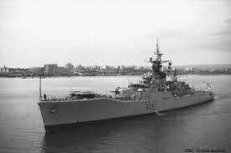 B. 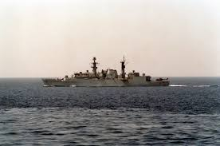

C. 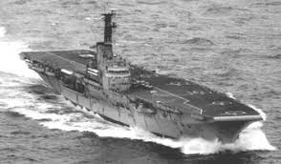 D. 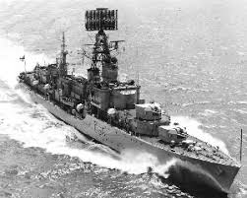
E. 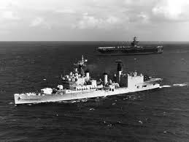
Q6. Which of our 1985 divisions shares a connection with the RN’s Submarine Service when operating under the noses of Axis forces from Malta during WW2?

Q7. How many of the Senior Divisional Officers from September 1985 can you name?
There’s a point for each – 6 in total. And, yes, we know where you can find out!

ROUND 2 – BACK TO BASICS (Training)
Q8. What might you find noted in your MOD Form S2910?
A. Your daily rate of pay
B. The date you received your AGR
C. Your blood group and religious denomination
D. Your BRNC mess number
E. Your journal articles

Q9. Basic naval history now. Which famous architect designed the college which opened in 1905?
A. Sir Christopher Wrenn
B. Sir Charles Barry
C. Sir Aston Martin
D. Sir Aston Webb
E. Sir Robert Webb

Q10 Right, off to the River for some messing about in boats before tea and stickies. Remember your life jacket! What are/were the 4 college yachts called, one being allocated to each Division?

And for a bonus point, once you knew your port from your starboard, you may have been selected to crew the college racing yacht, what was it called?

Q11. Two Bird Class patrol vessels were assigned to BRNC seemingly to introduce Officers Under Training to prolonged bouts of seasickness, as they were notoriously poor sea keepers, what were their names?

Q12. For another two points, who (according to BRNC legend) held the record for the Chapel to Senior Gun Room dash – and by what mode of transport was this record achieved?
Q13. Naval History now, pay attention at the back! Before the current college was built at Dartmouth in 1905, two former sailing hulks were used to introduce young cadets to naval life, one was named HMS Britannia, what was the other?
Q14. What school boy error(s) has alleged former BRNC alumni Shaun McBride (if that is his real name) made by selecting this particular front cover for his “complete guide to preparation for Royal Naval Officer Training”? Published in 2016 (PB) and available for a very reasonable £9.55. (Three marks available). Bonus point to anyone who has actually read it and can offer an ad-hoc 5 word review.
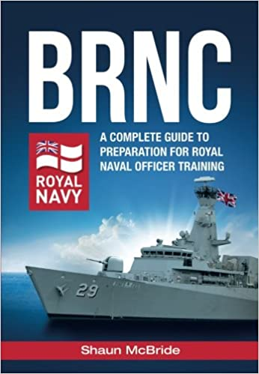
NB. I think we can all agree in 1985 he wouldn’t have been allowed in Cunningham Division – Shaun’s certainly not on the Soapy Watson approved list of appropriate first names for a naval officer, even for a Blake SL(X).
Round 3 – DTS - With Apologies to those who were not at sea onboard HMS INVINCIBLE and HMS MINERVA from Jan to Mar 1986. To compensate, we’ve added some general knowledge questions too for good measure
Q15. Re arrange the following anagrams to uncover some famous Caribbean runs ashore.
A. HOBDAY CATENA
B. NAUTICAL IS
C. FOULDERED ALTAR
D. DREADLOCKS SONNY
E. PYE MOP
Q16. What was the name of the supporting tanker which accompanied HMS INVINCIBLE and HMS MINERVA during some on our 1986 DTS (time to dig out those old RAS photos)?
A. RFA GOLD ROVER
B. RFA APPLELEAF
C. RFA FIGLEAF
D. RFA PEARLEAF

Q17. Who was the Commanding Officer of HMS INVINCIBLE during our DTS?
A. Captain Christopher “Kit” Layman
B. Captain Jeremy Black
C. Captain Hugo White
D. Captain George Tullis
E. Captain Andrew Tennille

Q18. Maintaining that theme of being in command, who was the Captain of the England Cricket Team at the time of their infamous 1986 West Indian Tour and therefore responsible for trying to pry a less than sober Ian Botham from the clutches of the Chef’s Messdeck off while anchored off Antigua?
A. Mike Gatting
B. Mike Brierly
C. Geoff Boycott
D. Alan Lamb
E. David Gower

Q19. On which island would you find Nelson’s Dockyard?

Q20. How many personnel were in the official DTS photo taken on HMS INVINCIBLE’s flight deck entering Fort Lauderdale? (Hats on).
A. 238
B. 328
C. 286
D. 228
(There’s a Pusser on our committee, hence we can be sure of the numbers, if nothing else)

Round 4 – Now That’s What I Call 1985

Q20. Arguably one of the most famous names in RN History, which ship was commissioned by HM The Queen Mother in November 1985?

Q21. Cast your mind back to those tinny transistor radios’ playing quietly in the corner of your cabin and annoying your fellow OUTs. What was the Christmas number 1 back in 1985?
A. Band Aid – Do they Know it’s Christmas?
B. Jackie Wilson - Reet Petite
C. Shakin Stevens - Merry Christmas Everybody
D. Cliff Richard - Mistletoe and Wine
E. Jefferson Starship - We Built this City on Rock and Roll

Q22. Who was the Secretary of State for Defence in 1985?

Q23. Back in those days we had top quality and intellectually stimulating TV broadcasting across all 4 channels, but leaving that all aside for a moment, who was presenting Blankety Blank on BBC1?

Q24. For two points, a major diplomatic incident occurred in 1985 when the Greenpeace trawler Rainbow Warrior was scuttled in which harbour; and by the security/intelligence apparatus of which foreign power?

Q25. Which enduring film trilogy kicked off in the summer of 1985 featuring an iconic stainless-steel product originally manufactured in a Belfast factory?

Round 5 – Caption Competition
Here we have a few photos randomly selected from the BRNC 85 Website to provide us with the opportunity for some creativity and levity, it’s been a tough year. So, what hilarious captions can you come up with to illustrate the following dubious images?
Q26.
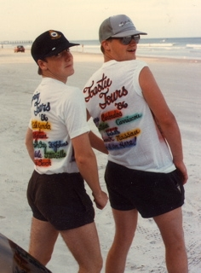
Q27.
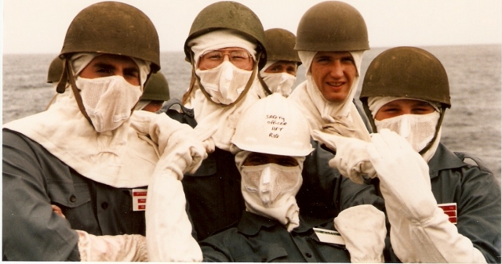
Q28.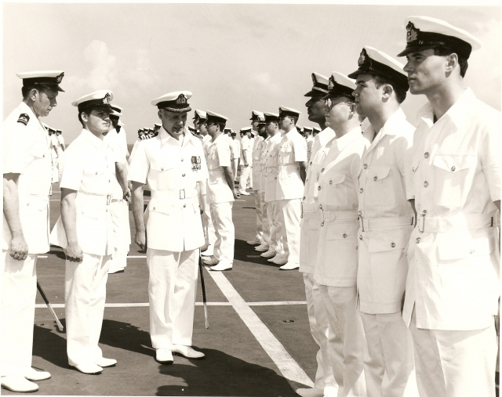

Round 6 – And finally, march off the guard and band! We’re back to more current affairs.
Q 29. What was the estimated cost of proposed repairs to the college in 2017 to bring it up to the basic levels of habitability and safety?
A. £20M
B. £30M
C. £40M
D. £60M
E. £80M
Q30. What unique (to date) event in RN training history happened at the college this year?

